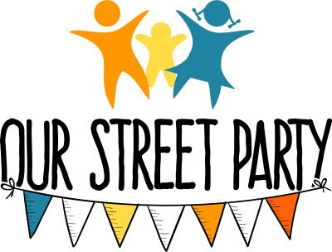
Get in touch!
contact:

Completing the street party application form

- You need to have
- Decided the date and time of your party.
- Decided where the street will be closed from/to.
- Flyered the street to let them know you want to plan a street party. We suggest a week’s notice for any concerns.

- The template form – The Herts form looks complex as it is designed for any road closure: utility works, bus diversions etc. I’m assuming you are not trying to close a bus route or main road. In which case just change the bits in green text. Ignore the bits about payment – currently there is no charge.

- Times - If you are not sure how long you want your street to close for – go for a longer time period on the application to be on the safe side. You don’t want to have to stop the party if people are just getting into the swing of things.

- Co-ordination checks – You need to check https://hertfordshire.roadworks.org/ to ensure there aren’t any relevant major roadworks or diversions scheduled for your proposed date. Select relevant dates using the calendar function in the top right. Enter the results on your application form. Minor small works with no diversions are unlikely to be an issue, or you could do a partial street closure to take account of this.

- Map - A map must be submitted with the application to show exactly what is being closed, This can now be a simple sketch on google maps or ordinance survey. We suggest:
Go to https://explore.osmaps.com
Zoom in to max on your street
Print out the image and add the following in pen
- The closure area (solid line)
- The route traffic would need to take to get around the closure (dashed line)
Then scan
- You could of course capture the image digitally and add the lines in Word or Photoshop. The example on page 2 was done in Word.
- Herts CC seem fairly relaxed about the map for street parties – please don’t get too hung up the map as long as it is clear what is being closed.

- Signs - For ordinary quiet residential roads there should not be any requirement to have advance notice signs up or road ahead closed signs or diversion signs (source: Department for Communities guidelines) You do, of course, need Road Closed signs, which can be made or vinyl ones bought.
- Charges - There is no charge in Herts for ordinary quiet residential streets that are not on a bus route.

- Submitting the form – Submit the completed form along with the map to TTRO@hertfordshire.gov.uk at least 6 weeks in advance of your party.
(It won’t hurt to ask for confirmation of receipt).
Need more help or need some inspiration?
Get in touch!

Example of Street Party map
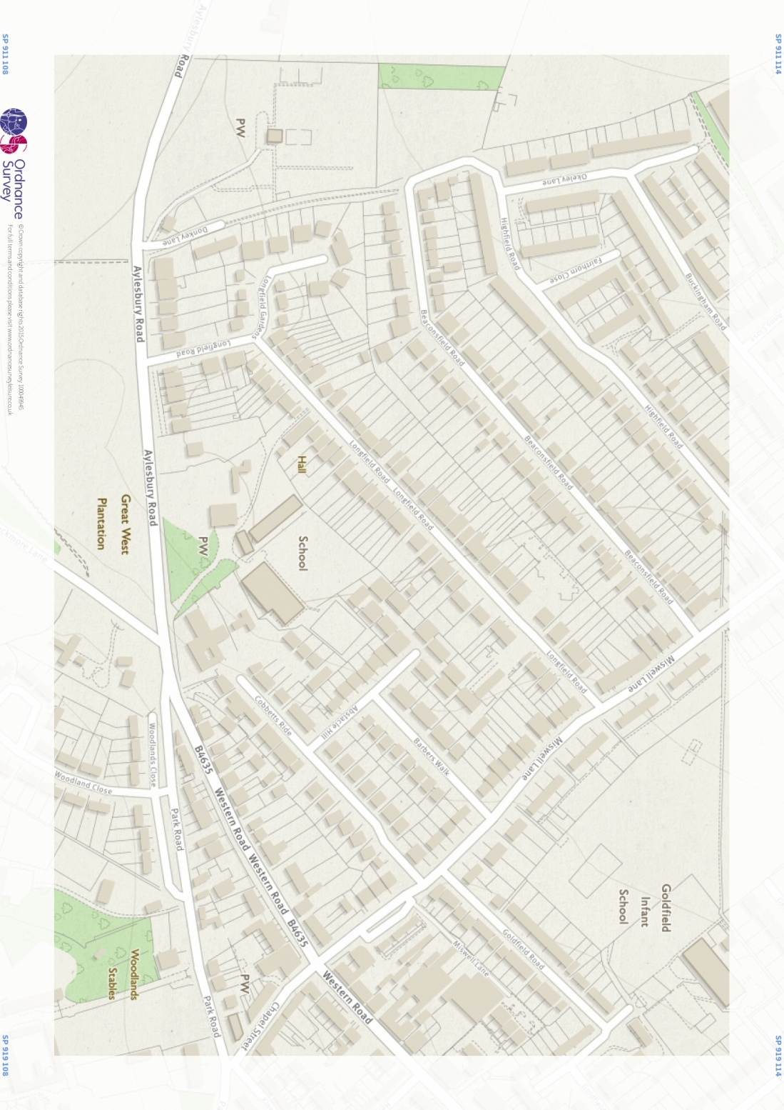
Section of [name of road] to be closed for street party
Route for diverted traffic

