Dacorum’s Den 2022 Winners Press Release
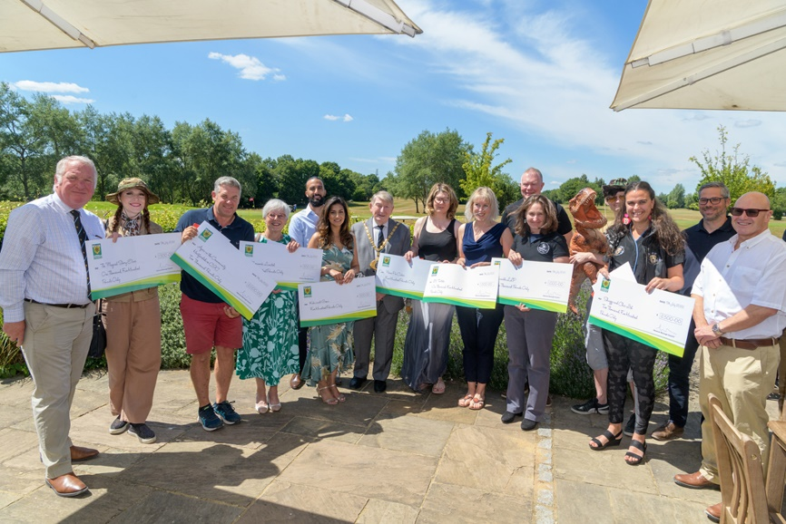

Dacorum’s Den 2022 Winners Announced
Eight budding entrepreneurs were awarded up to £2,500 for their businesses after they pitched their ideas to a team of Dacorum’s Den judges on Friday July 15, 2022.
The panel of four judges, led by Sir Mike Penning MP divided a total of £10,000 grant fund to a range of business ideas that included dog grooming, solar panel advisers, cake makers and a children’s theatre company.
As well as the financial support, the winners also receive one year’s free membership to the Hemel Hempstead Business Ambassadors and 6 months of free business support coaching provided by a local supplier, Action Coach.
The winning businesses were:
Lucy Baker, owner of Shaggy & Chic dog groomers was awarded £2,500 to purchase a new hydro-bath with a much quicker heating system, delivering energy efficiency, reduced water consumption and drastically reducing bathing times. The judges were so impressed with Lucy’s passion for dogs and her business that they awarded the amount required to fully fund the equipment she requires.
Stewart Hunt owner of Apex in the Community, Hertfordshire CIC was awarded £2,000 to fully fund a shipping container classroom facility and community garden. The judges were impressed by Stewart’s enthusiasm and commitment to providing community sports clubs and activities for schools via the community interest company he has set up.
Babbette Smith owner of The Magical Story Elves was awarded £1,500 to produce a show reel to promote her children’s entertainment company. Babette and her team sang and performed their pitch presentation in full costume and accompanied by a giant animated dinosaur! The judges liked the different presentation style and were impressed with the educational element of the business.
Jessica Thatcher owner of ZV Textiles received £1,500 towards advertising and marketing for her B2B textile manufacturing business in the equestrian and country clothing sector. The judges were impressed by Jessica’s concise presentation and the professional production set-up of her business.
Husband and wife team, Jan & Sarah Sisson owners of Sunsible LLP were awarded £1,000 to fund a new drone for their Solar advice and maintenance business. The new drone will allow them to capture roof-level images for inspecting solar and other renewables systems, helping homeowners keep energy bills at bay and reduce their carbon footprint.
Natasha Collins owner of Nevie-Pie Cakes received £500 to fund an edible printer so she can create her own edible printed images on specialised icing sheets to decorate and personalise cakes. The proof of the pudding is in the eating and the judges were impressed with the quality of the products and believe that the free support from Action Coach will help Natasha with her future business planning to further grow her business.
Anne Barnes & Caroline Scott, joint partners in Chocwork, a new start up business offering chocolate making workshops for adults and children, received £500 for another melting pot. This additional equipment will allow them to provide for bigger groups, they already have scouts groups interested in booking, and will also allow them a separate melting pot to cater for coeliacs.
Husband and wife team Rupal & Kamal Panchal owners of Kiki and Green received £500 for marketing investment in their environmentally friendly sanitary products business. The judges liked the environmental and ethical aspects of the business and their plans to recruit a marketing executive as their business grows.
The panel of judges was headed by Sir Mike Penning MP, who praised Dacorum’s Den as “a great initiative to help local businesses grow. There were some excellent pitch presentations from a wide mix of different business sectors and we look forward to seeing these businesses grow with the injection of finance plus the coaching and membership package”.
The panel of judges included Martin Fieldman, Managing Director at Abodebed, Andrew Hepworth, Managing Director at Sopra Steria and David Spratt, Head of Sales Business Systems at Epson (UK) Ltd.
Additional sponsors include the Marlowes Shopping Centre, Hemel Business Investment District (BID) and Barnard and Webb Solicitors. Barnard and Webb previously won in 2016 and wanted to give something back this year to support other growing businesses.
For more information on Dacorum’s Den 2022 visit the Dacorum Borough Councils website.
Dacorum's Den winners 2022
If you are a Dacorum business and would like to get involved with sponsoring this initiative next year, please email the Economic Development Team at Dacorum Borough Council on business@dacorum.gov.uk.

